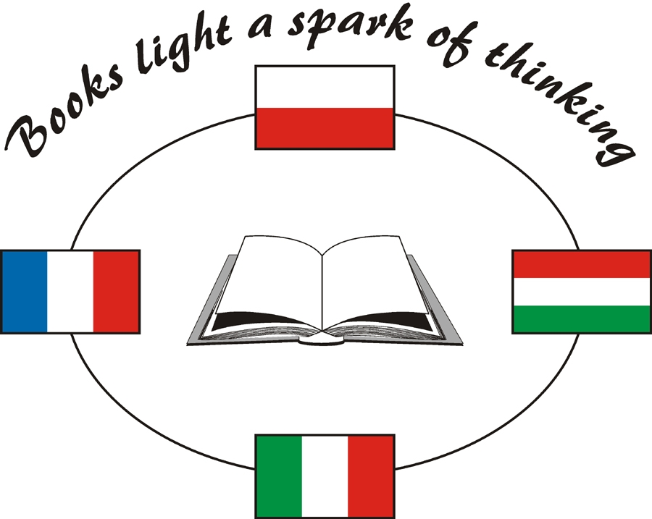
BOOKS
Reading
Taking apart
Drawing
Interpreating
Rebuilding

OUR ROOTS IN THE CLASSIC BOOK

Fairy tales
Stories
ENVIRONMENT

As integrating backgraund of education to activ citizenship

MULTIMEDIA

As opportunity to make every things

MEETINGS

Getting to know
Speaking English
Planning

COMENIUS PROJECT
Italy
France
Hungarian
Polland

